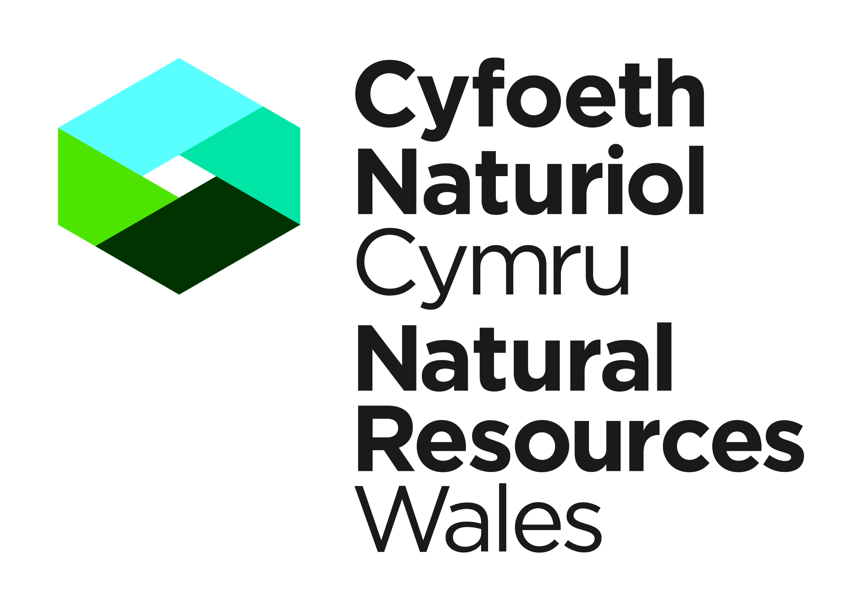
Permit Receipt Centre
Natural Resources Wales
Welsh Government Offices
Cathays Park
King Edward VII Avenue
Cardiff
CF10 3NQ
Ffôn ▪ Tel: 0300 065 3000
Ebost ▪ email:
permitreceiptcentre@naturalresourceswales.gov.uk

Filling out this form: You can either: - print this form and fill out the relevant fields using block capitals and in black ink or - fill out the relevant fields on screen, then click Print form. The form must then be signed and returned to the above address or sent by email.

APPLICATION FOR A MARINE LICENCE TO DREDGE FOR MARINE MINERALS

Please read the notes below carefully before you start to complete the form:

- The Natural Resources Body for Wales (hereafter “Natural Resources Wales”) Marine Licensing Team administers applications under Part 4 of the Marine and Coastal Access Act 2009 on behalf of the Welsh Ministers, who are the Licensing Authority.

- Generally, the MLT aims to process all applications within 12 weeks of receiving an application. However, some projects may raise matters that require a significantly longer time for consideration. This is most likely to be the case for applications to dredge marine minerals. Applicants are advised to contact the MLT as early as possible during the planning stage in order to avoid delays in determining their applications.

- These guidance notes are to help you complete the application form and provide the MLT with all the necessary information for your application to be efficiently processed.

- These guidance notes and application form should be used for applications relating to marine minerals dredging in Welsh waters (out to 12 nautical miles) only.

- Completion of all questions is compulsory for all applicants in order that the application can be fully considered. If you are unsure of how to complete any sections please contact the MLT.

- Applications must be accompanied by a chart and drawings showing the position of the proposed dredging area in relation to an identifiable coastal feature as referred to in 2(iii) below. If pipelines/cables or wrecks are located within a proposed area, applicants are advised to provide a chart showing the location of these and the exclusion zones that they propose to avoid interference with them should permission be granted.

Question 1 – Please include the name of the person who should be contacted in connection with this application. If an agent is acting for the applicant, all correspondence will be sent to the agent. Full details of joint applicants should be included (where appropriate) on an additional page which should be attached to this form.

Question 2 – Information under the following sections should be submitted in the format specified.

(iii) This section should describe the location of the area in relation to an identifiable coastal feature (i.e. x km off the coast of y town). This coastal feature should also be shown on the chart submitted under question 2(vi) below.

(vi) Co-ordinates shall be expressed in degrees and decimal minutes to 4 places of decimals by reference to the World Geodetic System 1984 datum (WGS 84 Datum).

Any changes to the information contained in this section, which an applicant may wish to make after the application has been submitted, must be notified to the MLT.

Question 3 – Full details must be provided. If the information is not available at the time of application, the MLT may require such information to be provided before determining an application. Any changes to the information contained in this section, which an applicant may wish to make after the application has been submitted, must be notified to the MLT.

Question 4 – Full details must be provided on what type of application it is. Please discuss with the MLT whether the proposed activity constitutes a variation or requires a new application.

Question 5 – This section details the requirements of the Marine Works (Environmental Impact Assessment) Regulations 2007 (as amended).

Question 6 – This section details the information to be submitted to support the application, where applicable. It is acceptable for a schedule of draft conditions to be incorporated within an Environmental Statement.

Question 7 – Full details of any European sites of conservation importance must be provided.

Question 8 – Full details of any other sites, such as wrecks must be provided, e.g. the area, reference number and relevant dates.

Question 9 – The application must be accompanied with the relevant fee. In the case of a variation, the MLT will notify the applicant of the level of the fee once the application has been screened.

Question 10 - All applications must be signed and dated confirming the declaration.

Further information
When preparing the application you are advised to take account of the Interim Marine Licensing Guidance Wales and the Interim Marine Aggregates Dredging Policy.

Data Protection Act 1998

The information provided will only be used in conjunction with your application. In limited circumstances, the Welsh Government may be required to release information, including personal data and commercial information, on request under the Environmental Information Regulations, the Code of Practice on Access of Government Information or the Freedom of Information Act 2000. However, the Welsh Government will not permit any unwarranted breach of confidentiality, nor will we act in contravention of our obligations under that Data Protection Act 1998. We will not divulge commercially sensitive information to anyone outside Welsh Government or contracted laboratories.

1. Applicant’s details (for joint applications, please specify all names, including the main point of contact – continue on a separate sheet as necessary)

Title (e.g. Mr/ Initials Surname
Mrs/Miss/Ms)

Full postal

Postcode

address

Telephone number Fax number (incl.

(incl national dialling code) national dialling code)

Email Mobile phone number

Details of agent (if appropriate)

Title (e.g. Mr/ Initials Surname
Mrs/Miss/Ms)

Postcode
Full postal
address

Telephone number Fax number (incl.

(inc national dialling code) national dialling code)

Email Mobile phone number

2. Proposed dredging area

- Area number

- Area name (if applicable)

- Location of the Area

(description)

- Co-ordinates Latitude

Longitude

(where necessary continue on a separate sheet)

- Size of Area (km²)

- Chart showing location of Area in relation to identifiable
coastal features enclosed…………………………………………….YES NO

3. Details of application

- Duration of marine licence……………………………….

- Proposed maximum annual tonnage……………….

- Proposed total amount to be extracted………….…

- Maximum depth of extraction proposed……………

- Type of mineral……………………………………….

- Extraction method

(e.g. trailer or anchor dredging)……………………

- Is screening of the dredged material to be undertaken?….YES NO

4. Nature of application

- Is the application for:

  - New marine licence?…………………………..….YES NO

  - Variation to an existing marine licence……..….YES NO

If you are applying for a variation, please give details of dates and reference numbers of existing permissions and an explanation of the proposed variation and the reasons for it. Please continue on a separate sheet if necessary.

- Details of previous Government Views (GVs) or dredging permissions/Crown Estate Licences relating to the Area (if applicable), including reference numbers, dates and area involved.

Issue date of Date of The Crown

GV or Permission….……. Estate Licence

Expiry date of
GV or Permission….…….

5. Marine Works (Environmental Impact Assessment) Regulations 2007

- Have you considered the works under the Environmental Impact Assessment Directive (Directive 85/337/EEC – as amended) on the assessment of the effects of certain public and private projects on the environment? If so, do you consider the works to fall within:

Annex I Annex II

- Have you applied for a screening or scoping opinion from the
MLT under the Marine Works (Environmental Impact

Assessment) Regulations 2007 (as amended)?.............YES NO

If YES, what is the reference?.....................................

(iii) Has an environmental statement/assessment been

undertake to support your application?.........................YES NO

6. Supporting information – If required, have you provided the following?

- Environmental Statement…………………………………. YES NO

- Coastal Impact Assessment………………………………. YES NO

- Schedule of draft conditions……….……………….……..YES NO

- Is the proposed Area within a wider Regional

Environmental Assessment (REA) study area? …..……YES NO

(v) (a) Has pre-application advice been sought as part

of this application?……..……………………….... … YES NO

(b) If pre-application advice has been sought, please list those bodies consulted, and attach the relevant correspondence where possible.

7. European sites of conservation importance

The consenting authorities have a duty to ensure that projects will not have significant adverse environmental impacts, particularly upon designated European sites of conservation importance, such as special areas of conservation (SAC), special protection areas (SPA), sites of special scientific interest (SSSI) or Ramsar sites and other areas listed under the Conservation of Habitats and Species Regulations 2010 (as amended). If the applicant (particularly if they have statutory powers for consenting aspects of these works) has been in consultation with the appropriate nature conservation body (Natural Resources Wales (NRW) or Natural England (NE)) it is likely to hasten processing of the licences if copies of all such correspondence are submitted with the application.

Please provide copies of correspondence with Natural Resources Wales or its legacy bodies or NE Please indicate below if no consultation has yet taken place.

- Are any parts of the proposed application area located

within 5km of, a European site of conservation importance?......YES NO

If YES, which designated site (s) does the application Area fall within?

- Please provide a description of measures proposed to avoid any impacts of European sites of conservation importance.

(v) If the application area is not located within 5km of a European site of conservation importance, please indicate the approximate distance of the boundary of the nearest European site of conservation importance………………………………..

8. Other features (such as wrecks)

- Is any part of the application area within 5km of a wreck or an

artefact of historical/archaeological interest? ……………..……..YES NO

If YES, please specify these, including a description of their nature and location.

9. Fees

The levels of fees for processing and determining the application are shown on the Natural Resources Wales website: https://naturalresources.wales/permits-and-permissions/marine-licensing/marine-licensing-fees-and-charges/?lang=en

Please note applications will not be processed without the relevant fee.

10. Declaration

I declare that to the best of my knowledge and belief the information given in this application form and related papers is true.

WARNING: It is an offence under the Marine and Coastal Access Act 2009 under which this application is made, to fail to disclose information or to provide false or misleading information.

Signature Date

For and on behalf of the applicant

Name in BLOCK LETTERS

Please check carefully the information you have given and that all the enclosures (including copies) have been included.

Where to submit the application

Applications for a marine licence to dredge for marine minerals must be submitted to:

Permit Receipt Centre
Natural Resources Wales
Welsh Government Offices
Cathays Park
King Edward VII Avenue
Cardiff
CF10 3NQ
Ffôn ▪ Tel: 0300 065 3000
Ebost ▪ email: permitreceiptcentre@naturalresourceswales.gov.uk

Applicants are reminded that this application is for permission to dredge for marine minerals under Part 4 of the Marine and Coastal Access Act 2009.

For Official Use Only
Application No. |  | Area No.
Area Name
(if applicable)
Date received |  | Date payment received
Amount paid |  | File reference

From 6th April 2011 previous permissions, issued under the Environmental Impact Assessment and Natural Habitats (Extraction of Minerals by Marine Dredging) (Wales) Regulations 2007 became marine licences.

